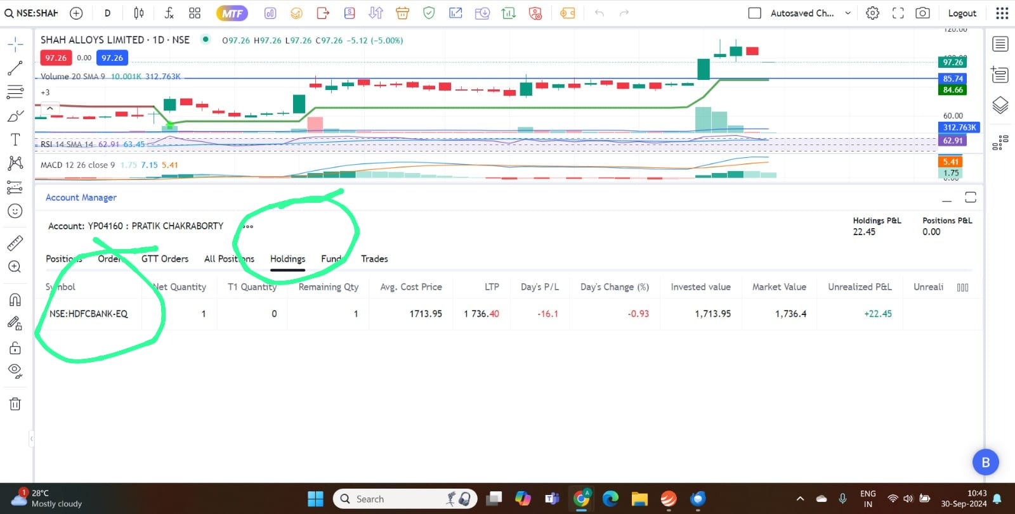
- In holding tab it is showing Hdfcbank stock.

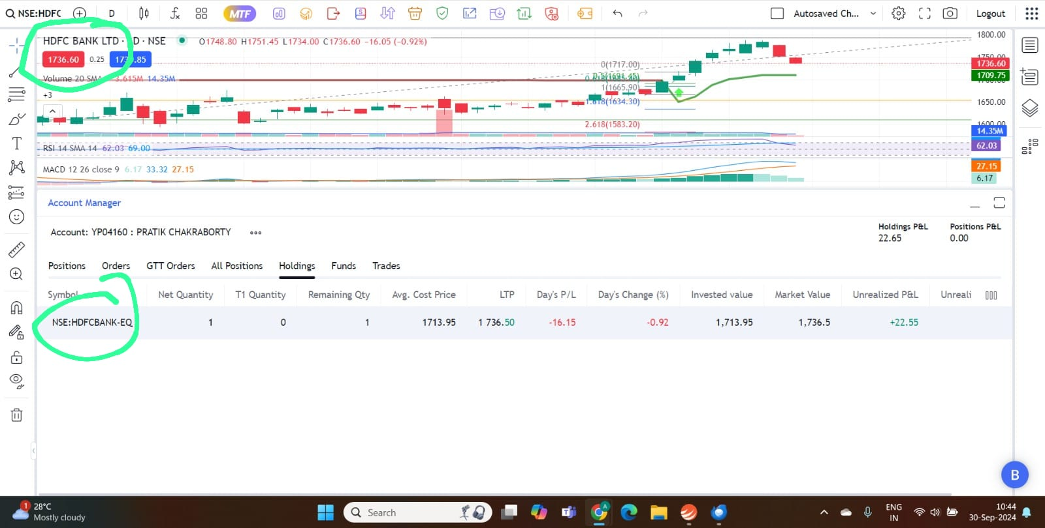
- Click on the stock name and it will appear on the chart above.

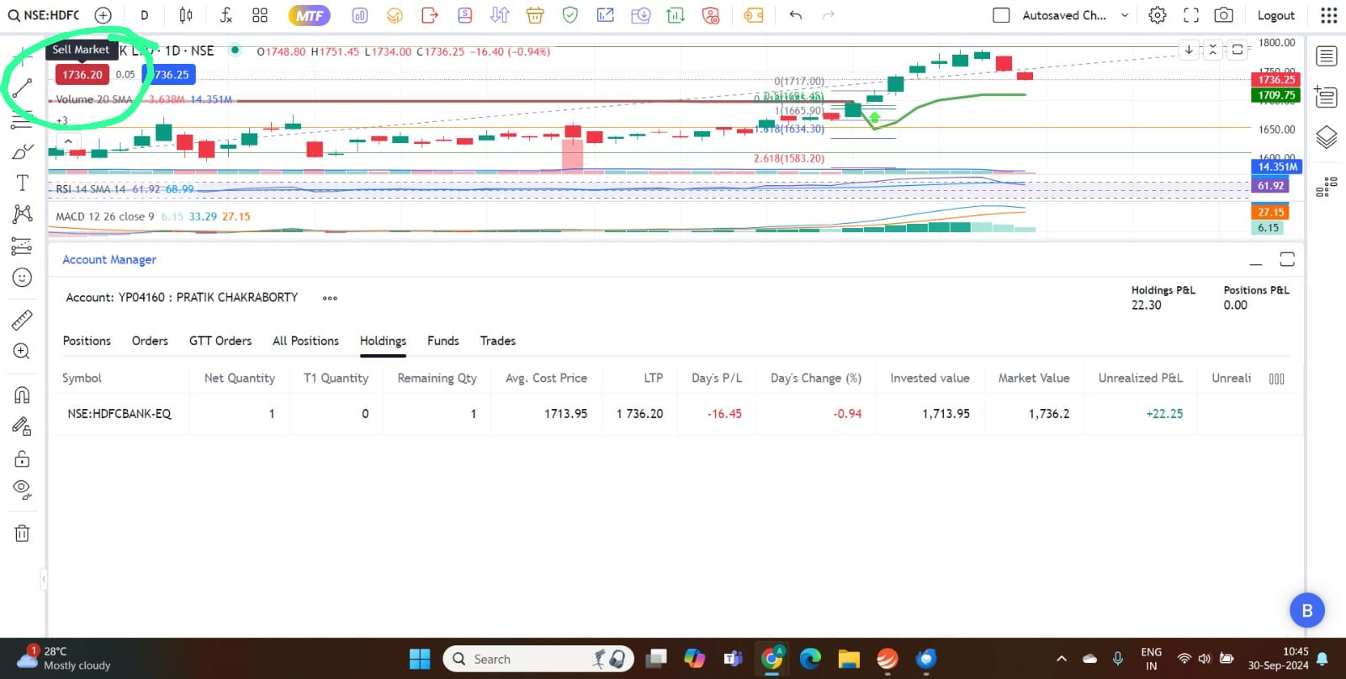
- Click on the sell button.

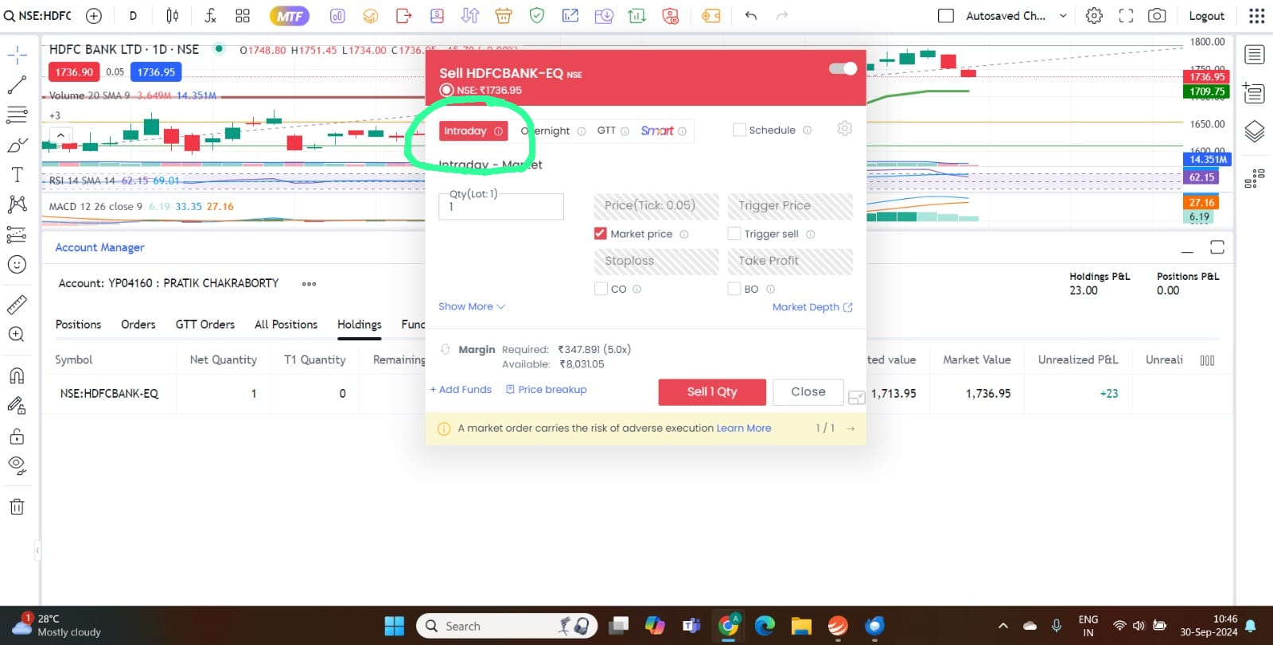
- Sell window will open. Default selection will be Intraday.

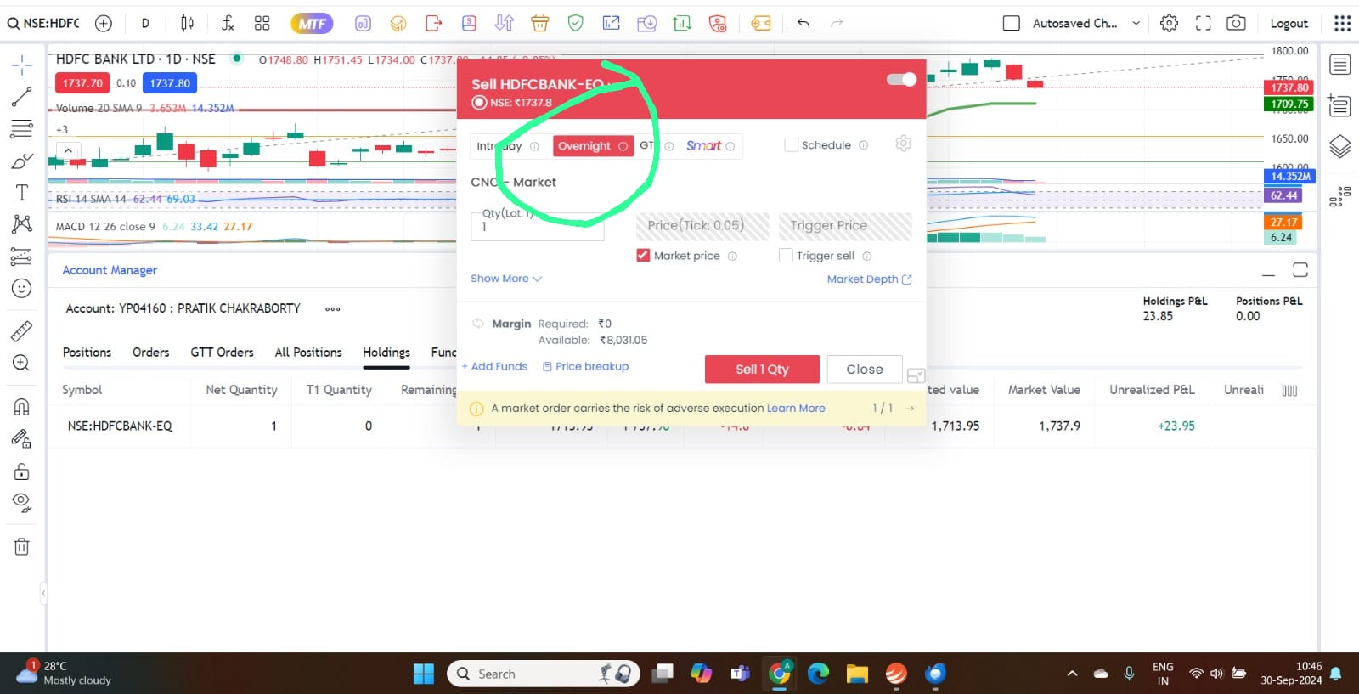
- Select overnight option. Selecting Market price check box will sell the stock at the best price available at that time.

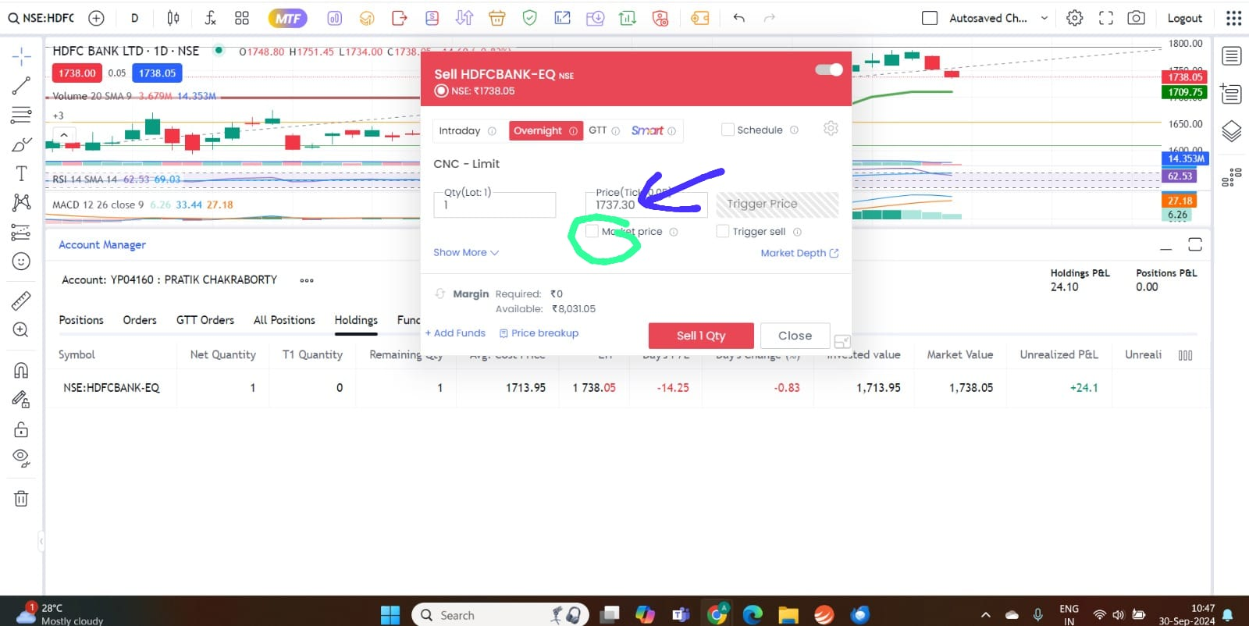
- If you want to sell the stock at a specific price, deselect the Market Price check box and enter the required price in the box above. Then click on sell button.
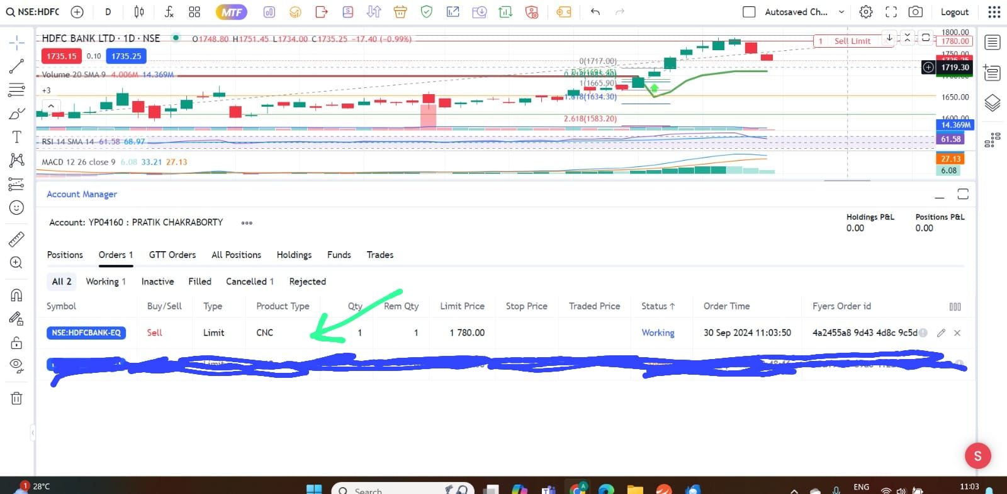

- After you click sell button, your order will reflect in the Orders 1 column.

